# This article is about the OT-One.

## **It's no-longer sold or actively supported by Opentrons, but we've kept this article here to help existing users. Please** [**see our OT-2 Support articles**](https://support.opentrons.com/) **for the most up to date information!**

## **Overview:**

Once your [labware is calibrated](http://support.opentrons.com/getting-started/how-to-calibrate-containers-and-pipettes/calibrating-the-deck) and saved on your deck, you'll need to calibrate your pipettes so that your robot can accurately deliver the volumes you need for your protocol. Click on the pipette in the containers list to save it's plunger positions. Also, make sure your [pipette is correctly installed](http://support.opentrons.com/getting-started/unboxing-your-robot/installing-pipettes) on your robot before attempting to calibrate.

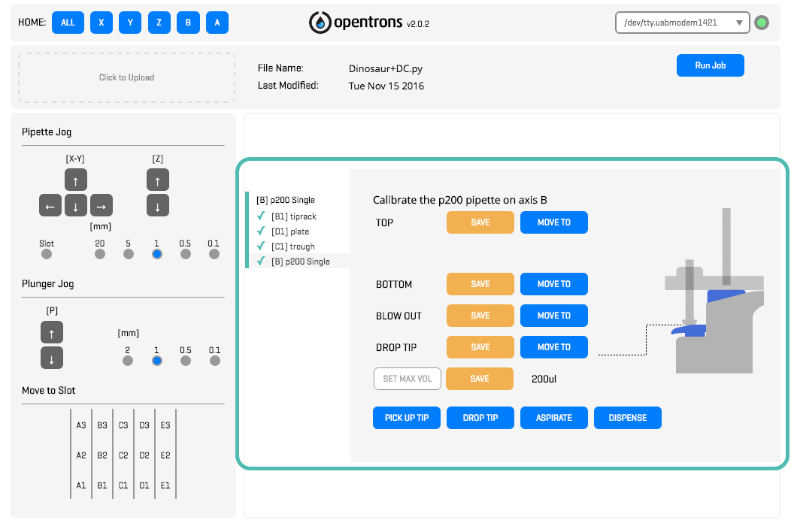

When calibrating pipettes, you'll save four positions: Top, Bottom, Blow Out and Drop Tip. The four positions allow the robot to accurately transfer liquids, to perform blow outs, and to correctly pick up and drop pipette tips. Make sure you have a tip on your pipette before beginning this process. Also, make sure you have your pipette plunger set to deliver the full volume range for which it is rated (ie, for the p200, twist the plunger and set the dial to 200 microliters).

To control these positions in the app, select the Pipette from the bottom of the containers list.

## **Procedure:**

You can control the plunger movements using the pipette jog buttons:

The four plunger positions that must be saved are the following:

* Top - Plunger is positioned almost all the way up (but still being pressed down just a tiny bit)



* Bottom - Plunger is at or slightly above it’s “first-stop” or “soft-stop”

Feel for the soft spot on the pipette plunger





* Blow Out - Plunger is all the way down to it's “second-stop” or “hard-stop”, making sure any attached tip do not get pushed off



* Drop Tip - Forces any attached tip to fall off



Each of the four positions has two buttons next to it in the App:



When the “SAVE” button is pressed, the robot’s current physical position will be saved as that plunger position. Pressing this button will overwrite any previously saved coordinate for that plunger position.



Pressing “MOVE TO” will cause the robot to start physically moving towards the position most recently saved, which is great for testing. For example, if I press the “MOVE TO” next to the “DROP TIP” position, the plunger will move to that saved position, and hopefully drop any currently attached tip.

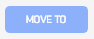

If a position has not been previously saved, the “MOVE TO” button will be greyed out until it has been saved.

The animated gif below shows what the process looks like to both find and save those four positions on your pipette. When you think you have arrived at one of the positions using the jog buttons, press the matching “SAVE” button for that position, and test it out with the “MOVE TO” buttons.

Once all four positions are saved, a green checkmark will appear next your pipette’s name in the containers list.

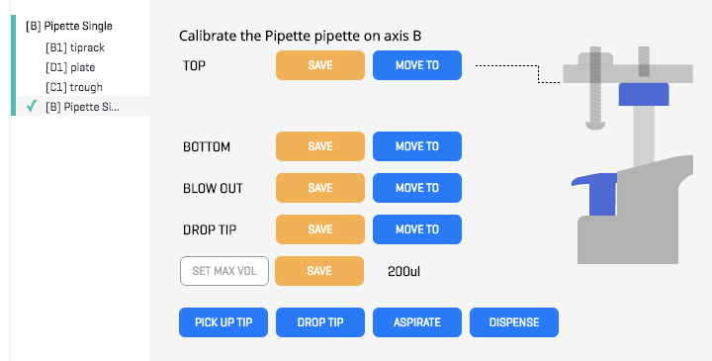

Once these plunger positions are all saved, you can test your pipette plunger accuracy via performing calibrations.

This is most easily done gravimetrically using a small scale. Use the "ASPIRATE" button to pick up liquid and then the "DISPENSE" button to dispense the liquid onto the scale. If this volume isn't exactly what you expect, maybe 203 uL instead of 200 uL, no big deal! You can input the value the scale gives you in the "SET MAX VOL" space and click "SAVE". The robot will adjust its calculations accordingly and will then be able to dispense the correct volumes during experiments!